


Computer Communications 25 (2002) 1076±1084

www.elsevier.com/locate/comcom

Minimizing re-routing in MPLS networks with preemption-aware
constraint-based routing
BalaВzs Szviatovszki^{a,}*, AВron Szentesia, AlpaВr J uИttner^{a,b}
aTraf®c Analysis and Network Performance Laboratory, Ericsson Research, P.O. Box 107, H-1300 Budapest, Hungary
bCommunication Networks Lab, EoИtvoИs University, PaВzmaВny PeВter seВtaВny 1/a, H-1117 Budapest, Hungary
Received 1 August 2001; revised 30 October 2001; accepted 28 November 2001

Abstract
In this paper, we study the effect of distributed constrained shortest path ®rst (CSPF)-based path selection on the dynamics of label
switched path (LSP) preemption. We propose new CSPF algorithms for minimizing preemption of lower priority LSPs without requiring any
enhancements to the recently proposed link-state parameters. The difference between priority-based path selection methods and previously
proposed CSPF methods lies in the way the selection is done among equal cost shortest paths. Our priority-aware CSPF algorithms decrease
the number of preempted lower priority LSPs while the LSP setup success ratio is basically the same for all methods. q 2002 Elsevier
Science B.V. All rights reserved.
Keywords: Path selection; Constrained shortest path ®rst; Traf®c engineering; Routing; Priority

1. Introduction

The differentiated services and multi-protocol label
switching (MPLS) working groups (WG) of IETF are
proposing architectural enhancements to the best-effort IP
infrastructure that make bandwidth reservation for aggre-
gate Їows a reality. The changes introduced to the IP
network architecture depart from the well-understood best-
effort IP world. Therefore, building stable, optimally
provisioned networks is a great challenge. Particularly,
computation of explicit paths when label switched paths
(LSPs) have bandwidth requirements is a complex issue.
There are basically two possibilities for path calculation:
local strategies for routing a single LSP versus global path
computation for network-wide optimization of resource usage.
The main bene®t of a local constraint-based routing
method is that each label edge router can automatically
compute explicit routes for LSPs. Constrained shortest
path ®rst (CSPF) routing implements a simple algorithm
to ®nd a feasible bandwidth constrained path in a capaci-
tated graph. When doing distributed path selection, there is
no information on future LSP arrivals. Therefore, CSPF
aims at minimizing resource usage by restricting path
* Corresponding author. Tel.: 136-1437-7631; fax: 136-1437-7767.
E-mail addresses: balazs.szviatovszki@eth.ericsson.se
(B. Szviatovszki), aron.szentesi@eth.ericsson.se (A. Szentesi),
alpar.juttner@eth.ericsson.se (A. JuИttner).

selection to a shortest path that satis®es the bandwidth
constraints. However, CSPF in itself cannot always yield
network-wide optimal paths, since it uses only local infor-
mation. It is the role of global path optimization to achieve
network-wide optimal usage of resources.
In MPLSРas we will discuss in more detail in Section
2РLSPs, beside having a bandwidth requirement, have
also setup and holding priorities. All MPLS protocol
components support bandwidth reservation on different
priority levels. Between these levels LSP preemption is
supported. If at path setup, there is not enough free band-
width available on a link, lower priority LSPs will be
preempted [1]. MPLS speci®es eight different priority
levels; therefore, it can happen that by taking another path
a preempted LSP again preempts lower priority LSPs.
Although in current MPLS deployments mostly a single
priority level is used, there is signi®cant ongoing work at
the traf®c engineering WG aiming at the development of
ef®cient priority-aware LSP handling in MPLS networks,
in order to be able to support traf®c engineering in a differ-
entiated services environment. Thus, LSP-level traf®c
prioritization and preemption will play an important role
in the networks of tomorrow.
To the best knowledge of the authors, there have
been little work on the dynamics of LSP preemption. A
notable exception is Ref. [2], in which Villamizar
studies failure scenarios and the effect of independent path
re-computations and delayed re-Їooding of new resource

0140-3664/02/$ - see front matter q 2002 Elsevier Science B.V. All rights reserved.
PII: S0140-3664(02)00025-7

B. Szviatovszki et al. / Computer Communications 25 (2002) 1076±1084

1077

reservations on overall network performance. This work
suggests timing and ordering strategies for re-routing and
re-optimization of LSPs after failures, but does not deal with
path computation methods.
There are global optimization algorithms that consider
the issue of preemption. Garay and Gopal in Ref. [3] studies
preemption in asynchronous transfer mode (ATM)
networks. Their objective is to ®nd the minimum number
of calls that should be removed from the network in order to
have enough capacity to accept a new call. This optimiza-
tion method can only be implemented in a central place,
since detailed knowledge is needed about the path of each
and every call in the network. Similarly, Mitra and
Ramakrishnan [4] provide multi-commodity Їow solutions
for the global LSP optimization problem which can be used
for multi-priority traf®c as well.
As we will discuss in more detail in Section 3, all
proposed CSPF algorithms operate in a simple way regard-
ing LSP priorities. When computing the path for an LSP,
reservations of lower priority LSPs are not taken into
account. Known CSPF methods try to maximize the success
probability of future connection establishments, thus
prepare for future connection arrivals.
In this piece of work, we study the effect of CSPF-based
path selection methods on the dynamics of LSP preemption
in MPLS networks. As the main contribution of this paper,
in Section 4 we propose new CSPF algorithms that take into
account the present state of the network by considering the
available resource reservation information of lower priority
LSPs as well. By doing this, our algorithms aim at minimiz-
ing preemption of lower priority LSPs and thus, enhance the
stability of multi-priority MPLS networks. In Section 4 we
®rst show that, in order to have some idea of affected lower
priority LSPs, useful measures can be deduced from the
currently Їooded link-state information of interior routing
protocols (IGPs). Based on these measures, we propose two
methods to select such a shortest path on which the prob-
ability of preempting lower priority traf®c is the lowest.
In Section 5 we compare the preemption performance of
the CPSF algorithms proposed in this paper to the most
important methods discussed in the literature. To help the
understanding of LSP preemption and thus, the dynamics of
multi-priority MPLS networks, we ®rst show results that are
general for all CSPF methods. Then we study in detail, how
the performance of CSPF algorithms differs, in terms of
preemption. Presented results show that by concentrating
on preemption minimization we do not adversely affect
the success rate of the CSPF algorithm, however, the
probability of preempting lower level LSPs during an LSP
establishment is improved. Finally in Section 6 we conclude
the paper and propose future research topics.
2. Preemption in MPLS networks
In this section, we give an overview of the bandwidth
reservation and preemption related attributes and mechan-
isms of MPLS and show how these are used by constraint-
based routing to select paths for traf®c trunks, and by other
traf®c engineering mechanisms (e.g. preemption), to
achieve service differentiation.
2.1. Traf®c trunk attributes
Traf®c engineering extensions of the resource reservation
protocol (RSVP) [5] and the label distribution protocol
(LDP) [6] include `holding' and `setup' priorities. Setup
priority speci®es the importance of an LSP establishment,
while holding priority speci®es how important it is for an
established LSP to hold on to its reserved resources. Both
priorities have a range of 0 (highest priority) to 7 (lowest
priority). An LSP with higher (numerically lower) setup
priority can preempt an LSP with lower (numerically
higher) holding priority. To avoid continuous preemption,
holding priority should never be lower than setup priority.
2.2. Resource related attributes
IGP extensions of the open shortest path ®rst (OSPF) [7]
and the intermediate system to intermediate system (ISIS)
[8] routing protocols propose to Їood the maximum band-
width (B_{MAX})and the maximum reservable bandwidth (B_{max})
of a resource. The latter may differ from the actual
maximum bandwidth, because administrators may choose
to dedicate only part of the link's bandwidth to traf®c
engineering, or, to exploit statistical multiplexing gain the
reservable bandwidth may exceed the actual bandwidth of
the link.
The most important IGP extension to enable preemption
is the one in which actual resource reservations are
distributed. In Refs. [7,8] unreserved bandwidth B_{u}
B_{u0}; B_{u1}; ј; B_{u7}is speci®ed as the amount of bandwidth
not yet reserved at each of the eight priority levels on a
speci®c link. This is counted in an accumulative way i.e.
if a highest priority LSP is established, all elements of this
vector will decrease.
All Їooded resource information is stored in a traf®c
engineering database (TE-DB) of label edge routers. The
TE-DB is in turn used by constraint-based routing to select
paths.
2.3. Constraint-based routing
As we have mentioned in Section 1, the aim of CSPF in
MPLS networks is to automate the path selection for LSPs.
To achieve this, operators should con®gure resource and
traf®c trunk attributes and deploy a path selection algorithm
that matches these attributes against each other. In MPLS
the simplest bandwidth constrained CSPF works as follows.
Considering an LSP with setup priority s and bandwidth
requirement B_{LSP},
1. in the router's TE-DB mark all links as `invalid' where

1078

B. Szviatovszki et al. / Computer Communications 25 (2002) 1076±1084

the link's unreserved bandwidth at the priority level of
the LSP's setup priority is less than the LSP's bandwidth
requirement B_{us}, B_{LSP};
2. run Dijkstra's shortest path algorithm on the graph
composed of the links not marked as invalid. The result-
ing path (if there is any) will be the LSP's path.
The above algorithm when looking at the B_{us}level, treats
lower level reservations as if they were not present, there-
fore, when the LSP's PATH message traverses the explicit
path, preemption decision and admission control is needed
at each hop. The former determines which lower priority
LSPs will be preempted. The later is essential, since in case
of inaccurate link-state information, it can happen that there
is not enough unreserved bandwidth at the LSP's priority
level.
2.4. Admission control and preemption decision
The admission control function at each router checks
whether there is enough unreserved bandwidth to support
the setup of the new LSP. In case there is enough totally
unreserved bandwidth at an interface, no preemption is
needed, so admission is allowed. If this is not the case, the
setup priority in the PATH message is taken and a check is
made to see if established lower priority LSPs can be
preempted. If B_{us}, B_{LSP}there are not enough preemptable
LSPs so the PATH message is refused. Otherwise, as many
lower holding priority LSPs are preempted as needed.
The selection of the LSPs to be preempted is a local
matter. Local preemption strategies for two priorities have
been studied by Peyravian and Kshemkalyani in Ref. [9].
We use in the rest of this paper a straightforward extension
of their Min_Conn algorithm to support the eight priority
levels of MPLS. In this strategy until there are LSPs on the
(n 1 1)th priority level, LSPs cannot be preempted from the
nth level.
An LSP may preempt more LSPs when moving down-
stream. For the preempted LSPs, a noti®cation is sent up-
stream. Preemption does not differ from any other kind of
failure, so the head-end tries to re-route the LSP. Preempted
LSPs when re-established may further preempt other ones,
so a preemption chain may start.
3. Previous work on bandwidth constrained path
computation methods
In this section we give an overview of bandwidth
constrained path selection methods proposed in the litera-
ture. Since most of the proposed methods can be realized as
an extension to Dijkstra's well-known shortest path algo-
rithm, we use the terminology of Ref. [10] for describing
differences between presented algorithms. To make path
selection bandwidth constrained, all methods start by prun-
ing non conforming links based on the bandwidth check
B_{us}, B_{LSP}. In Ref. [10] this operation is described with an
acceptor function.
The Dijkstra algorithm aims at ®nding the best candidate
path to a node. For this, at each step two paths are compared
with the help of a comparator function [10]. At this point,
the used metrics have an important role. In case of single or
mixed metrics, the comparator function simply evaluates
which path's metric is smaller. In the original Dijkstra algo-
rithm this means the simple arithmetic comparison of two
real numbers (weights or `distances'), but for more compli-
cated metrics this comparison can be more advanced.
To provide more path optimization possibilities besides a
simple shortest path selection, many algorithms use the
concept of multiple metrics [11] which can be easily incor-
porated into Dijkstra's algorithm. Simply, when comparing
the metrics of two links or paths, the initial comparison is
done according to the ®rst metric (e.g. the con®gured link
cost or hop count as a metric), and in case of equality, the
value of the second-level metric breaks the tie (i.e. the
available bandwidth in case of the widest shortest path
algorithm).
To make the picture complete, for each metric an
accumulation function [10] de®nes how the metric is accu-
mulated along a path. When we know the distance to a node
and also we know the cost (metric) of the edges starting
from that node to the neighbors, we use this function in
the Dijkstra algorithm to determine the candidate distances
to the neighboring nodes. In an accumulation function,
depending on the type of metric, different operations are
done. Hop count or cost is an additive metric, so simply
the link costs should be summed to get the path cost. Bottle-
neck bandwidth is the minimum of available bandwidth
metrics along a path, so this is a concave metric.
Guerin et al. [12] propose OSPF extensions to support
QoS routing. They propose the widest-shortest path algo-
rithm (WSPF) for the bandwidth-constrained routing
problem. The main idea of this algorithm is to ®rst prune
links without suf®cient unreserved bandwidth and then
compute a shortest path on the remaining graph. When
several shortest paths are available, the preference is for
the path whose bottleneck link unreserved bandwidth is
maximal. This strategy aims at using minimal amount of
network resources and at balancing load.
The residual bandwidth ratio method (RB-CSPF) [10]
selects the bandwidth constrained shortest path for an LSP
such that as the second metric instead of the bottleneck link
unreserved bandwidth, it takes into account the bandwidth
that is still unreserved after the LSP setup, normalized by
the total reservable bandwidth B_{us}2 B_{LSP}= B_{max}: More-
over, instead of treating only a single bottleneck link,
storing and using a con®gurable number of bottleneck
links is described in Ref. [10] (e.g. four).
The WSPF and the RB-CSPF methods both aim at
balancing load. However, there are many load-based routing
algorithms proposed in the past for different networks [13±
15] that use longer paths than the topological shortest one.

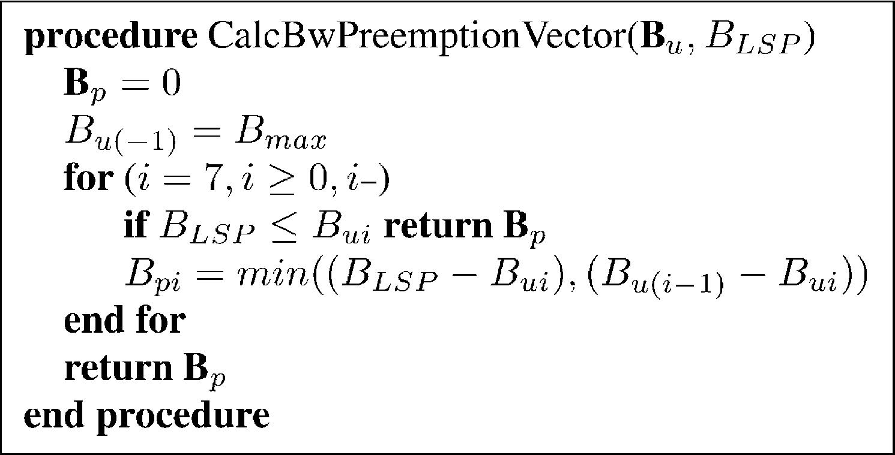
B. Szviatovszki et al. / Computer Communications 25 (2002) 1076±1084

1079

All such algorithms are common in their basic idea to
prepare for future call arrivals.
In Ref. [16] Shaikh, Rexford and Shin propose a load-
based additive link-cost metric as a second metric in the
Dijkstra algorithm. They propose this to be used after the
original link-cost metric which restricts path selection to
shortest paths. Their link-cost metric uses discretization,
in order to increase the probability of ®nding equal cost
paths.
In Ref. [17] Shaikh, Rexford and Shin propose bandwidth
constrained path selection for long-lived IP Їows. Their
path selection method is a widest-shortest path method.
However, pruning of bottleneck links are done after the
Dijkstra computation. Therefore, it can happen that among
the topological shortest paths none can support as much
bandwidth as requested. For this reason, Ref. [17] permits
the use of non minimal paths whose hop-count is one more
than the shortest path's hop-count.
In Ref. [11] Wang and Crowcroft studied the complexity
of the multi-constraint QoS routing problem. They proposed
the shortest-widest path algorithm, i.e. their ®rst constraint
is to ®nd a path with maximum bottleneck bandwidth, and
when there are more such widest paths, choose the one
which is the shortest.
Ma, Steenkiste and Zhang in Ref. [18] propose the
`shortest-distance' algorithm that can dynamically balance
the impact of hop count and path load. In their link cost
formula a variable n can be used to tune the algorithm,
i.e. by choosing n 0; we get the shortest path, and if
n ! 1, we get the widest path.
Ma and Steenkiste in another work [19] compare path
selection algorithms for traf®c with bandwidth guarantees.
The widest-shortest, the shortest-widest, the shortest-
distance and a variant of the `dynamic-alternative routing'
methods were simulated. The experiments showed that
algorithms limiting the hop count and, by this, resource
consumptionРe.g. the widest-shortest path and the
dynamic-alternative routing methodРprovide good results
when the network is becoming overloaded. On the other
hand, algorithms aiming at balancing the network loadР
the shortest-widest and the shortest-distance algorithmР
perform better in light and medium load situations.
Recently, authors of Ref. [14] showed that `minimum inter-
ference routing' outperforms both simple `minimum-hop'
routing and widest-shortest path routing. The price of better
results is, however, the complexity of the proposed
algorithm compared to simple Dijkstra-based methods.
4. Proposed preemption-aware CSPF methods
In this section we propose preemption-aware CSPF
methods that aim at minimizing unnecessary preemption
and thus enhancing the stability of MPLS networks. First
in Section 4.1 we derive new measures to estimate how
much preemption will occur on a path at LSP establishment.
Then in Sections 4.2 and 4.3 we show that these measures
can be used to construct new metrics and CPSF algorithms,
respectively.
4.1. Preemption measures
To have practically relevant results we have to take into
account technological limitations present in MPLS
networks. Currently proposed IGP extensions [7,8] provide
only summarized information about the reserved resources.
This means that they do not provide per-LSP information on
distant links, i.e. neither the number of LSPs nor their band-
width values are available. This summarized information is
suf®cient for CSPF route computation, i.e. to tell if a link
has the required resources to accommodate a new LSP on a
certain priority level. However, it is insuf®cient for deter-
mining how many and how big LSPs will be preempted due
to a setup of the new connection. Moreover, when traversing
more links, we cannot tell whether e.g. two times 20 Mb/s
will be preempted or only once. The latter case occurs when
LSPs preempted on the ®rst link automatically free
resources on the second link, thus eliminating the need for
further preemption.
Although detailed LSP information is not available at
path computation, it is still possible to develop heuristic
methods for minimizing the volume of preemption, based
on strictly the currently available standard IGP extensions.
4.1.1. Free bandwidth
In order to implement priority-aware CSPF algorithms in
a label edge router, we should identify useful preemption
measures. It is easy to see that if we are given a link and an
LSP to be established on it (for which B_{us}, B_{LSP}holds), the
bandwidth that should be preempted on the link will be
larger if we have smaller amount of free bandwidth
(unreserved bandwidth on the 7th priority level:
Bfree B_{u7}). By using free bandwidth as a measure we
actually achieve the simplest preemption-aware widest
path selection. This allows us to take into account lower
priority reservations and to minimize the amount of band-
width preempted by the new LSP.
4.1.2. Per priority preempted bandwidth
Besides the above discussed measures, we show that per-
priority preempted bandwidth also has an important role.
Let's de®ne B_{p}as the vector of bandwidth values that should

Fig. 1. Calculating the bandwidth preemption vector.

1080

B. Szviatovszki et al. / Computer Communications 25 (2002) 1076±1084

be preempted at each priority level of a link by the new LSP:
B_{p}B_{p0}; B_{p1}; ј; B_{p7}: 1
The above bandwidth preemption vector provides us useful
information. With its help, we can derive for example which
is the highest affected priority level on a link, i.e. the
smallest such number i for which B_{p}i±0: Fig. 1 shows a
procedure for estimating the bandwidth preemption vector
(considering the preemption strategy de®ned in Section
2.4). For an explanation of how this procedure works, the
reader is referred to Ref. [20].
4.1.3. Example
Suppose we have an LSP with B_{LSP}70 Mb=s band-
width requirement and s 3 setup priority. Now let us
take three 100 Mb/s links and suppose that from the Їooded
unreserved bandwidth vectors we have calculated the
following bandwidth preemption vectors:
B1_{p}0; 0; 0; 0; 30; 20; 0; 0 ; B1_{u7}20 Mb=s
accumulator function in which the bottleneck link's free
bandwidth determines the path's metric. The comparator
function is de®ned such that it chooses the path with larger
free bandwidth as a better candidate path.

4.2.2. Minimize affected priority levels
When using the bandwidth preemption vector (B_{p}) as a
link metric, we aim at minimizing the affected priority
levels, by preempting only as low priority LSPs as possible.
We de®ne the comparison operation for this metric as B1_{p},
B2_{p}iff for their ®rst (from 0) different coordinate with index
i, B¹pi , B²pi:
With this de®nition the comparator function actually
implements two tie-breaking concepts. If two paths have
different highest affected priority levels, the choice is for
the path on which the affected highest priority level is
smaller. But if the affected levels are the same, selection
of the candidate path is done by selecting the path which has
smaller preempted bandwidth on the highest affected
priority level.

B²p 0; 0; 0; 0; 0; 10; 30; 30 ;
B3_{p}0; 0; 0; 0; 0; 20; 20; 30 ;
B²u7 0 Mb=s
B3_{u7}0 Mb=s:
In order to minimize the affected priority levels (B_{p}) along
the path of the LSP setup, we propose to treat B_{p}as a
concave metric in the accumulator function (i.e. the larger
vector is taken as the path's metric).

We show how the discussed measuresРfree bandwidth and
bandwidth preemption vectorРcan be used, to decide
which link is more desirable to be used at path selection.
By looking at the affected priority levels, we can see that
on the ®rst link there is bandwidth to be preempted on the
lowest four priority levels, while on the second and the third
one only the ®fth level is affected. It may be important to use
such links for path setup on which only lower priority levels
are affected. We can also notice from the bandwidth
preemption vector that the second link has less affected
bandwidth on the ®fth priority level than the third one.
This makes the second link more desirable than the third
one.
However, if we consider free bandwidth, we can notice
that on the ®rst link there is 20 Mb/s free bandwidth, while
on the other two links, there is no free bandwidth at all. This
can make the ®rst link the most desirable.
4.2. Priority-aware CSPF metrics
Based on the above measures (B_{p}and Bfree) we construct
preemption minimization metrics that can be used in CSPF
algorithms. We de®ne how the above derived preemption
measures are used as path metrics in the Dijkstra algorithm
with the help of comparator and accumulator functions.
4.2.1. Maximize free bandwidth
By maximizing free bandwidth (B_{sum}) as a link metric, we
aim at preempting the fewest possible lower priority LSPs in
terms of sum bandwidth and among those paths on which no
lower priority LSPs are preempted, we choose the widest
one. Since bandwidth is a concave metric we de®ne such an
When no preemption is needed, we would like to use the
widest path. We achieve this by incorporating free band-
width with negative sign as a last (ninth) element in the
bandwidth preemption vector (2B_{u7}is used since preempted
bandwidth is to be minimized, while free bandwidth is to be
maximized).
4.3. Priority-aware CSPF algorithms
The order of metrics in the comparator function of CSPF
algorithms has huge signi®cance. We propose such an
ordering for our new metrics that minimizes preemption
without adversely affecting the CSPF success ratio and
path length of high priority LSPs. To achieve this, in both
algorithms we ®rst prune links for which B_{us}, B_{LSP}(s is the
setup priority of the LSP for which the path is calculated).
On the resulting graph we restrict path selection to shortest
paths based on the original OSPF metric. By using the link
cost as the ®rst metric in the comparator function of the
Dijkstra algorithm, we achieve that the LSPs are always
routed on shortest paths irrespective of lower priority traf®c.
We utilize preemption information only after this, i.e. when
selecting a candidate path among otherwise shortest feasible
ones.
5. Numerical results
We have conducted numerical investigations in order to
show the real improvements resulting from the use of our
algorithms. In Section 5.2 we describe the simulation
environment, survey the implemented algorithms and

B. Szviatovszki et al. / Computer Communications 25 (2002) 1076±1084

1081

measurements, then in Section 5.3 we introduce our simula-
tion experiments.
5.1. Performance evaluation methodology
Several different approaches are used for the performance
evaluation of routing strategies. For example, Plotkin [13]
proposes an analytical approach for this purpose. Another
method is to use discrete event simulation, assuming a
stochastic process for the arrival of demands [15].
In our case, it was hard to ®nd a tractable analytical
approach that can be used to obtain practical results. So,
we decided to use Їow-level simulation for our performance
evaluation purposes. In the literature there has not been
published any well-established and justi®ed LSP demand
arrival model for MPLS, nor was such available from opera-
tors. Therefore we have decided to omit the time factor from
our simulations. This means that instead of discrete event
simulation we evaluated the performance of the algorithms
by observing their behavior in a series of `static' traf®c
con®gurations.
5.2. Simulation model
5.2.1. Network and traf®c model
In order to have practically relevant results we carried out
our simulations on the cable and wireless backbone network
topology. This real life data network contains 31 backbone
nodes and 102 links, resulting in an average node degree of
3.29. The link capacities vary between DS-3 and OC-192,
with the majority of link having OC-12 capacity. The exact
topology and capacity values of this network (valid as of
June 26, 2000) are publicly available in Ref. [22]. We
supposed that demands are generated from every node to
every other node.
Since it is hard to get traf®c statistics from real MPLS
networks, we created randomly generated traf®c situations.
This means that we have loaded the network to a certain
extent with randomly placed LSPs having random band-
width values. LSP bandwidth is uniformly distributed
within the interval (0, BMaxLSP]. In our experiments we
focus on such situations when BMaxLSP is around 8±10% of
the most common OC-12 link capacity. The priority levels
of the LSPs were also set randomly with uniform distribu-
tion in [0±7].
5.2.2. Simulation setup
In our investigations we were interested how different
performance metrics change as network load increases.
Therefore, in our simulations, ®rst, we loaded the network
to a certain level by generating LSPs randomly between all
nodes. After this, we randomly generated several new LSPs,
and tried to route them with the selected CSPF method. In
case load increased above the required level after a success-
ful LSP setup, we randomly released some LSPs from the
network, until we returned to the operation point used in the
given simulation experiment. This test has been conducted
at different traf®c situations, resulting in a series of prob-
ability estimates describing the quality of the routing
strategy at different points. Numerous measurements have
been taken at each point in order to ensure 95% con®dence
intervals. In fact, in our graphs con®dence intervals are very
small and would not provide too much additional informa-
tion, so, for the sake of better visibility, we decided not to
show them in the ®gures.
We characterize a traf®c situation by the total throughput,
i.e. the sum of all established LSPs' bandwidth. We use total
throughput as a measure instead of average link utilization
on the x-axis, since we believe that carried traf®c is more
important to operators than link load. The CSPF failure ratio
is inЇuenced primarily by the average link load in the
network. However, at a given average link load, different
CSPF algorithms may have different amount of carried LSP
volumes. For example if one algorithm does ineffective path
selection at an early stage it results in longer paths for LSPs
routed afterwards. This means that at the same average link
load less amount of carried LSP volume is achieved. Conse-
quently if we measure the total throughput instead of
average link utilization, we may also investigate the effect
of higher average link loadsРcaused by ineffective path
selectionРon the CSPF failure ratio.
5.2.3. Compared algorithms
We investigated the performance of the proposed
priority-aware CSPF algorithms and compared it to the
most promising CSPF algorithms surveyed in Section 3.
According to Ref. [21] multiple priority levels, and preemp-
tion among them can be used to assure that high priority
traf®c trunks are always routed through relatively favorable
paths (i.e. shortest path). This suggested that we should
concentrate only on such algorithms that use strictly shortest
feasible paths.
Therefore we simulated the following algorithms
proposed in the literature: the basic shortest path ®rst
algorithm as a reference (`random'), the widest-shortest
algorithm (`widest') [12], the residual bandwidth ratio
method (`residual bw') [10] and the discrete link cost
method [16]. In the plots we name the algorithms based
on the used second level metrics shown in brackets. We
use the term random for the simple Dijkstra algorithm
because without a second level metric it does a random
selection among equal cost paths.
Moreover, our two preemption-aware algorithms were
implemented: the maximize free bandwidth method (`max
free bw') and the minimize affected priority levels method
(`min affected levels'). The latter was implemented with the
help of the bandwidth preemption vector measure. We have
incorporated the free bandwidth measure as the last element.
Therefore, at light loads when no preemption is needed, a
widest path selection is done, based on the free bandwidth.
5.2.4. Performance metrics
We compared the behavior of the implemented

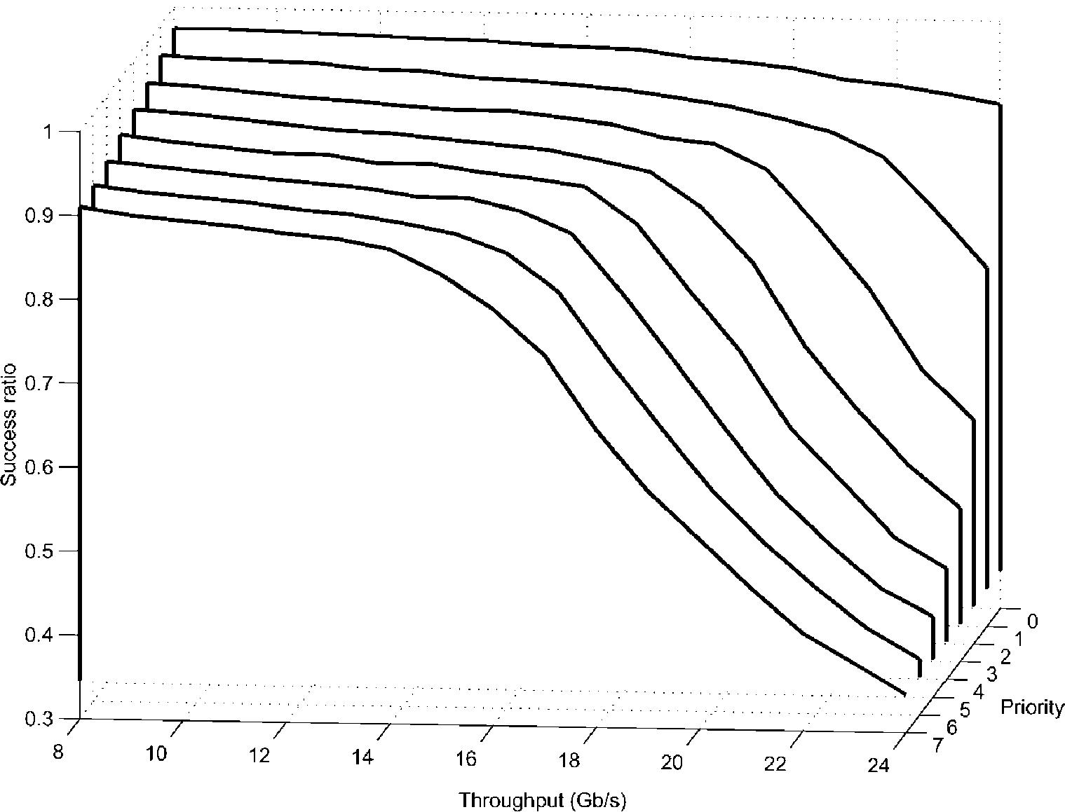
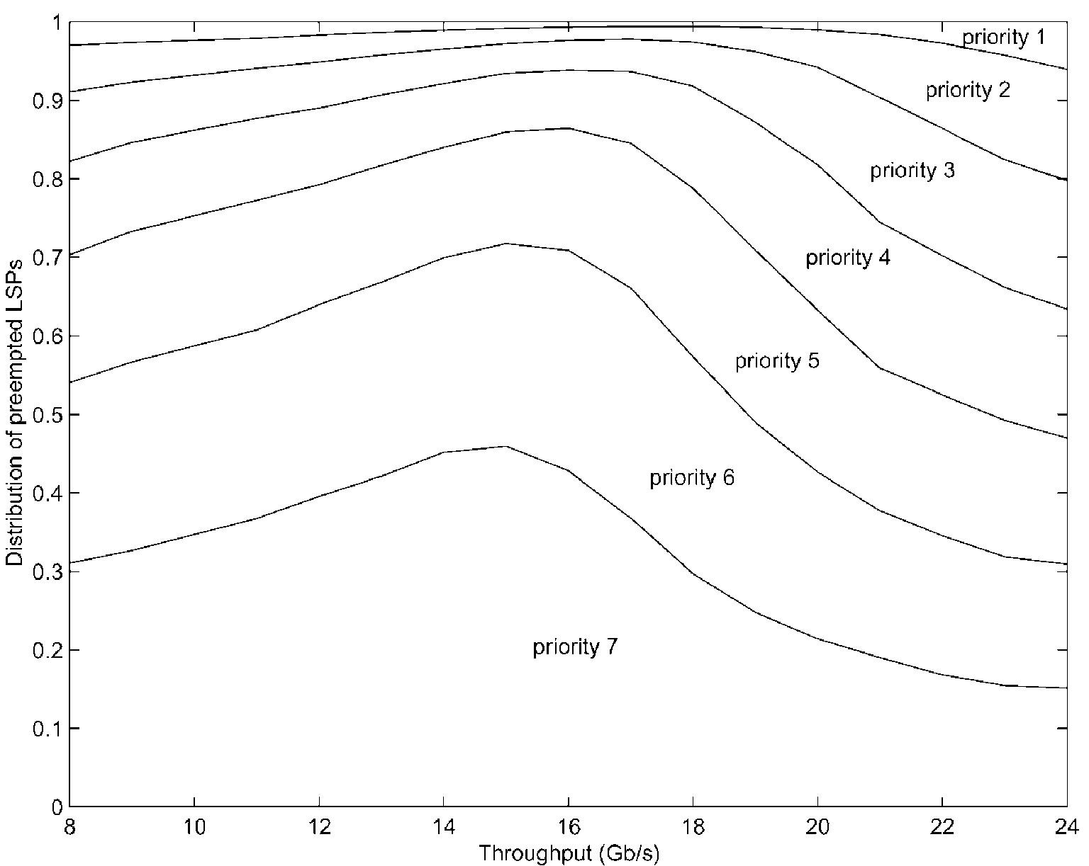
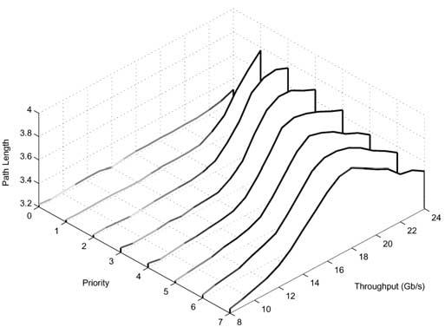
1082

B. Szviatovszki et al. / Computer Communications 25 (2002) 1076±1084

algorithms with the help of the following empirical
measures:
І Success ratio: measure of CSPF path computation effec-
tiveness. This measure provides information about how
many path computation attempts failed due to that CSPF
could not ®nd a feasible path for the LSP with the
required bandwidth.
І Success ratio per priority: path setup success ratio
differences are measured for the eight priority levels.
І Preemption ratio: the probability that during an LSP
establishment at least one lower priority LSP is
preempted.
І Distribution of preempted LSPs between the priority
levels: in the nominator we count how many times an
LSP with a given priority has been preempted. In the
denominator we have the total number of preempted
LSPs.
І Path length per priority: average path length of LSPs of
different priority levels.

5.3. Performance evaluation
In Section 5.3.1 we ®rst show the effects of preemption on
the widest-shortest path method, then we present experi-
ments of the priority-aware CSPF algorithm in Section
5.3.2.

5.3.1. General preemption effects
In our ®rst experiments we show plots for the widest
method to demonstrate general effects of preemption on
the performance of LSPs with different priority levels.
In Fig. 2 we can see the success ratio seen by the eight
priority levels (priorities are represented on the z-axis, with
`0' representing the highest priority, and `7' the lowest one).
We can notice that success ratio (the complement of CSPF
failure ratio) starts to decrease at much smaller total
throughput levels for the low priority LSPs than for higher
ones. The reservation differentiation concept with (i) multi-
ple priority levels, (ii) link pruning and (iii) cumulative
calculation of unreserved bandwidth values achieves that

Fig. 2. Success ratio per priority (for the widest method).

Fig. 3. Distribution of preempted LSPs between the priority levels (for the
widest method).
reserved resources of higher level LSPs cannot be used by
lowest level LSPs. The effect of this can be seen on the
decreased success ratio of lower priority LSPs.
Per priority success ratio provides information about such
LSPs that are to be established. However, lower priority
LSPs are not only affected by CSPF failure, but also by
being preempted by higher level LSPs. To have an idea of
which priority levels were preempted, we counted
altogether how much LSPs were preempted, and also, how
much LSPs were preempted at each priority level. From this
we determined the distribution of preempted LSPs between
the priority levels, as shown in Fig. 3. Highest priority LSPs
can never be preempted, therefore, `priority 0' is not shown
in the ®gure. LSPs with `priority 1' are on the next level,
thus, these can be only preempted by level 0 LSPs.
However, on a link before these relatively high priority
LSPs are preempted, the local preemption algorithm
discussed in Section 2.4 always tries to preempt lower
levels. The probability that among all preempted LSPs a
`level 1' LSPs is preempted increases only when actually
almost all lower levels are removed from network links. At
this time traf®c is dominated by `level 0' and level 1 LSPs.
On the contrary, at low total throughput values, 35±45% of
the preempted LSPs are `priority 7' LSPs.
It is interesting to check the effect of preemption on the
path length of LSPs in Fig. 4. In case of constraint-based

Fig. 4. Path lengths of different priority levels (for the widest method).

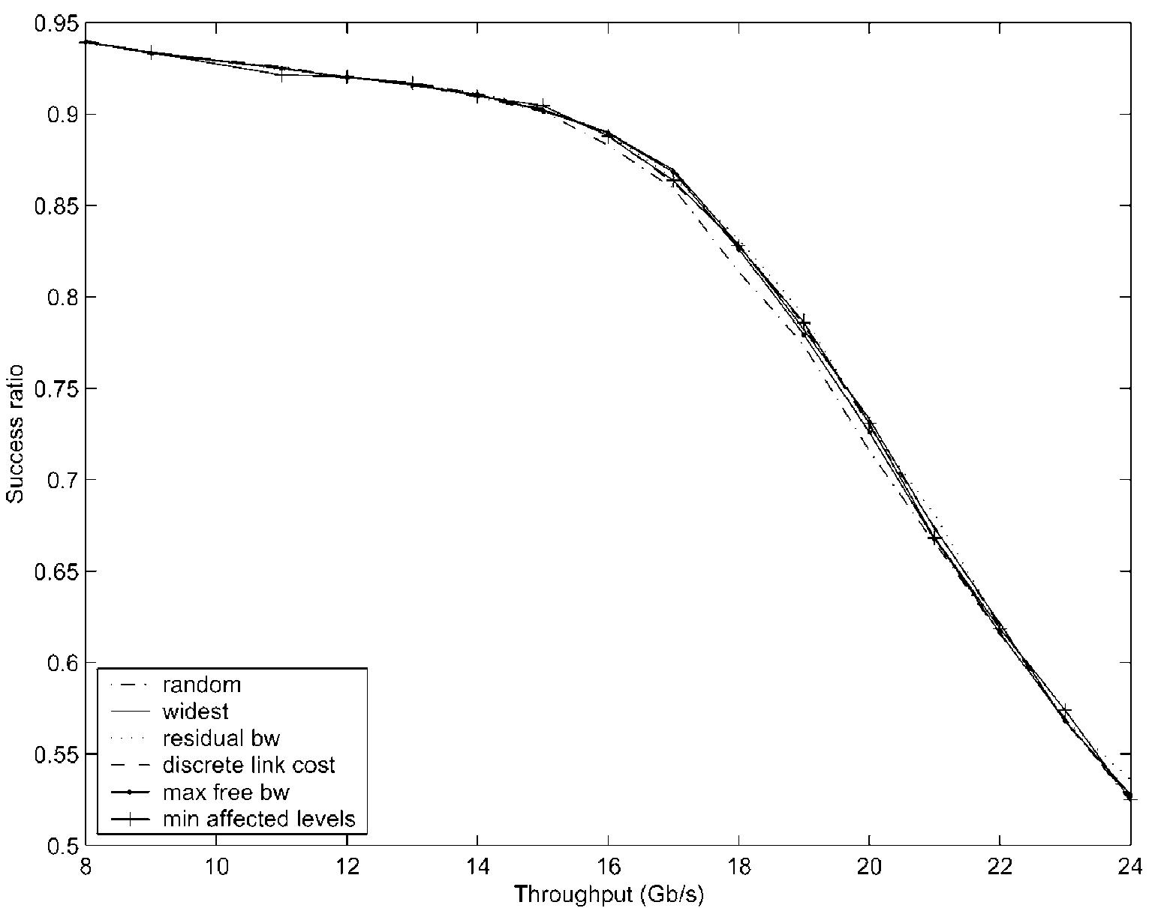
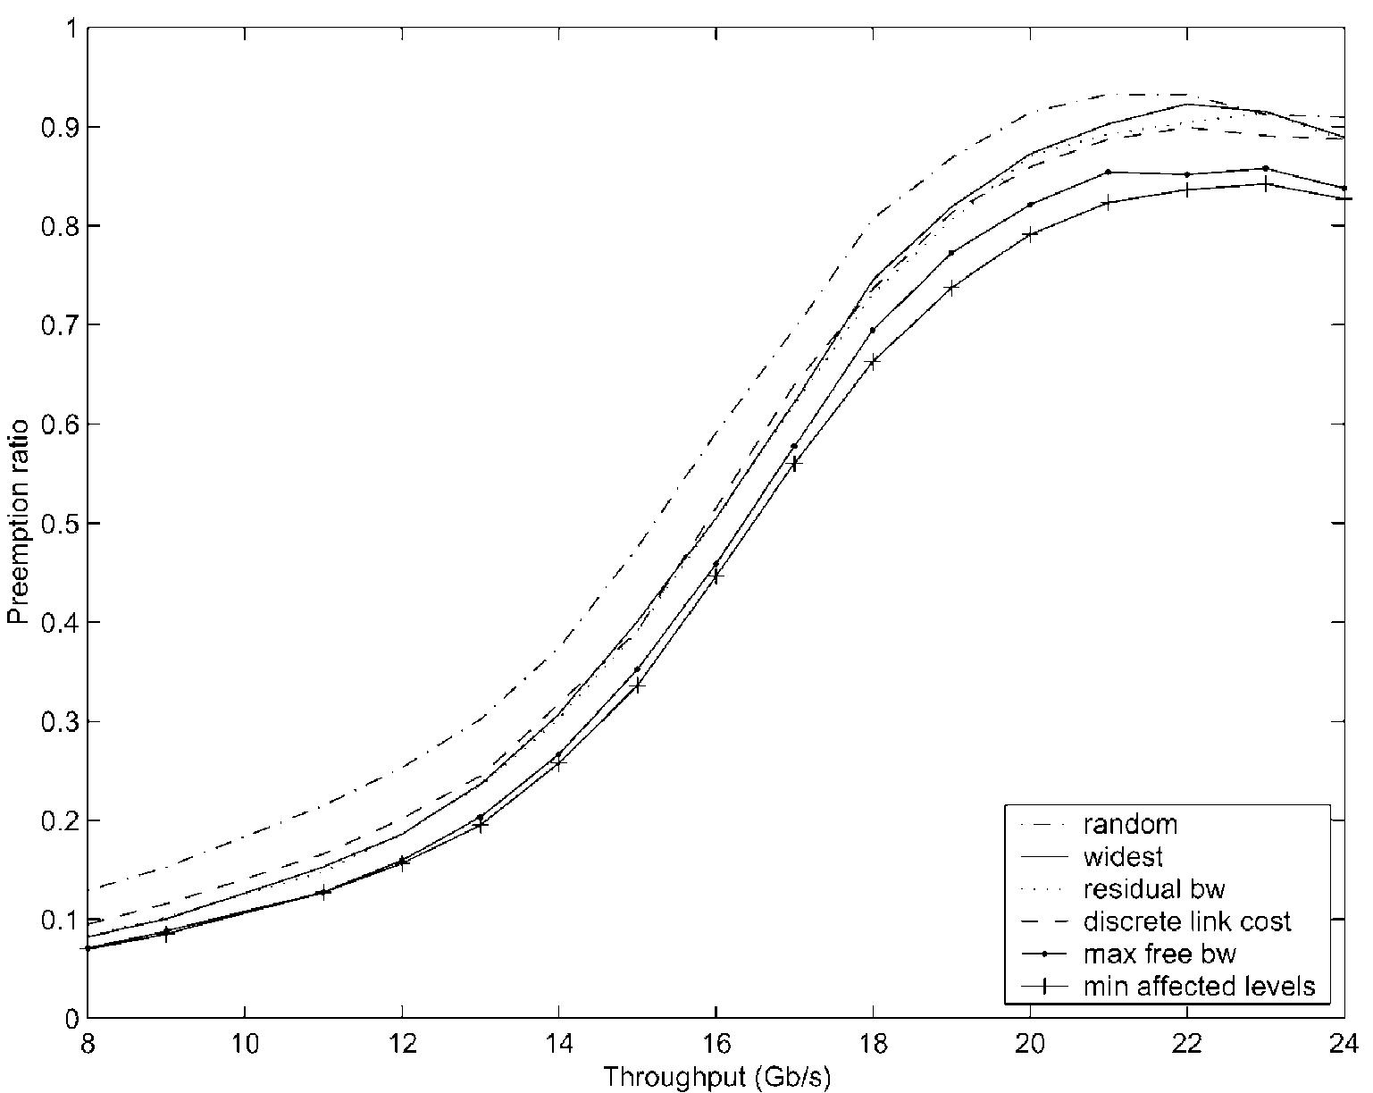
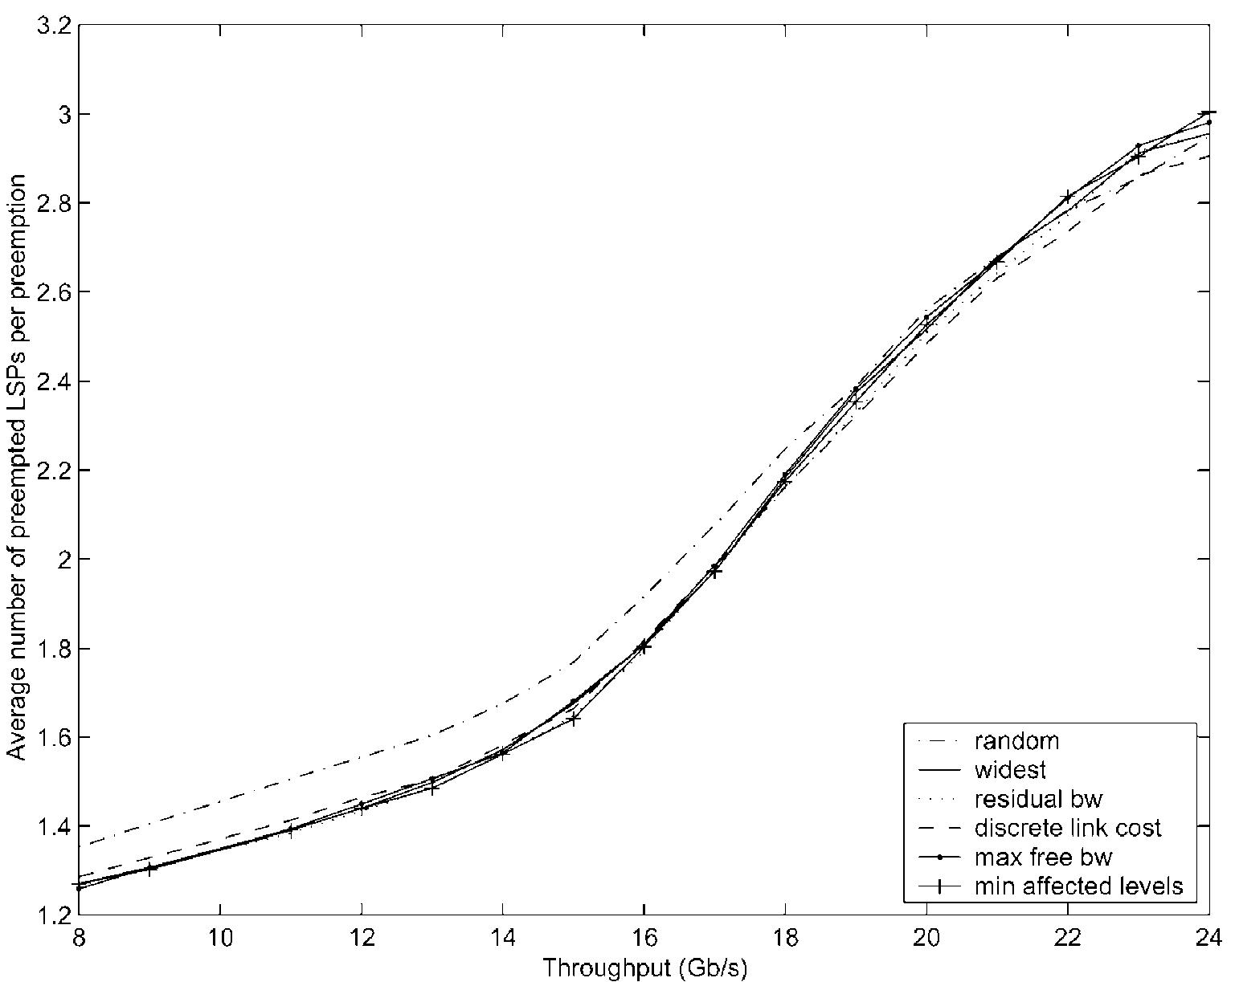
B. Szviatovszki et al. / Computer Communications 25 (2002) 1076±1084
routing, path lengths are also inЇuenced by the bandwidth
constraints, i.e. the link loads. In Fig. 4 we can observe that
at light link loads, for all priority levels the path length is
around 3.2 hops. As link load increases ®rst the path length
increases, then it starts to decrease. The basic reason for this
is the following: in Fig. 2 when for a priority level CSPF
failure increases, it means that it is hard to ®nd a feasible
path for LSPs. At this stage, most probably the topologically
shortest paths do not have enough unreserved bandwidth, so
only longer bypass paths can be used. Typically, for all
priority levels, when success ratio decreases to 60±80%,
the path length increases. However, after a given load
level, preemption effects path length, since it is more prob-
able to preempt LSPs established on long paths. At the same Fig. 6. Preemption ratio.
time LSPs having their source and destination nodes closer

1083

to each other will have a bigger chance to be established
successfully. Therefore, after a critical level, path length of
established LSPs decreases.
5.3.2. Impact of preemption minimization
In this section we present main preemption performance
differences between CSPF algorithms. As we see in Fig. 5,
the most important measure, the overall LSP establishment
success ratio is roughly the same with all CSPF methods.
This means that the probability that the LSP can indeed be
established on the computed path is the same with our
proposed preemption minimization methods as with e.g.
the widest method. This result is not surprising, since
previous simulations have also shown [19] that CSPF
algorithms (shortest-distance, widest-shortest and
dynamic-alternative routing methods) achieved almost the
same success rate. If we take into account that in our case all
the simulated algorithms restrict path selection to shortest
paths, it is not surprising that the success rate differences are
small.
The difference between widest and random methods
(roughly 3%) are much larger than differences between
the proposed preemption minimization methods and
previously proposed CSPF methods. The success ratio is
lower for the simple random method compared e.g. to the
widest method, since the random method may block links at

Fig. 5. Success ratio.
an early stage, which forces LSPs arriving later to use longer
paths. We can observe that our preemption measures, by
trying to avoid such links on which preemption is probable,
actually balance load similarly to the widest path and other
load-based CSPF algorithms.
To quantify the gain in preemption minimization, we
used preemption ratio as a basic measure. In Fig.6 it is
shown that the probability of preemption is signi®cantly
lower for our proposed methods. Moreover, we can notice
that our strategy to minimize the affected priority levels is
more effective than the simpler one that maximizes the
bottleneck free bandwidth of the path. We determined
from numerical data that at high loads (18±22 Gb/s through-
put) the former achieves 10%, while the latter 5% improve-
ment compared e.g. to the widest method. At light loadsР
which is more important since this is in fact the normal
operational range of a typical networkРboth strategies
decrease the preemption ratio by approximately 15%,
which is a signi®cant improvement.
When preemption occurred, we measured the average
number of affected LSPs (Fig. 7). This includes the directly
affected LSPs and also the LSPs preempted by the
preempted LSPs that were re-established (chain effect).
We found that when preemption occurs, the number of
LSPs in the preemption chain does not differ signi®cantly
for the different methods. Consequently, we can say that the

Fig. 7. Average number of preempted LSPs per preemption.

1084

B. Szviatovszki et al. / Computer Communications 25 (2002) 1076±1084

main bene®t of using our method can be found in decreasing
the probability of preemption, and not in preempting less
LSPs when preemption is unavoidable.

6. Conclusions and future work
In networks supporting traf®c with diverse QoS require-
ments, setup of low priority traf®c should be done in such a
way that subsequently arriving higher priority traf®c is not
effected adversely. A simple way to solve this problem is to
allow preemption between the priority levels. In this paper
we have investigated the effects of bandwidth constrained
path calculation on the preemption process. The cornerstone
of our method is to do path selection by taking into account
resource utilization of lower priority traf®c. In the studied
MPLS environment, we have shown that premium quality
can be achieved for high quality LSPs, even if we target
preemption minimization.
As a basic step for our preemption minimization
algorithms, we have speci®ed preemption measures calcu-
lated from standard Їooded unreserved bandwidth informa-
tion. One measure estimates the amount of bandwidth that
will be affected, while another one quanti®es how many
levels will be affected by the new LSP's setup. These
measures are then used to construct metrics that are directly
applicable in a modi®ed shortest path ®rst algorithm. We
build on Dijkstra's well-known shortest path ®rst algorithm,
because of its speed. Our modi®cations increase the running
time of the original algorithm by a constant factor.
Our simulation experiments demonstrate that the
proposed priority-aware path selection algorithms signi®-
cantly outperform traditional load-balancing CSPF methods
in terms of the total number of preempted lower priority
LSPs, thus, it results in less re-routing in the network. In
addition, we have found that this is achieved by retaining
equal path establishment success ratio. We obtained the
best results when, with the help of a second metric, we
aimed at minimizing the affected priority levels.
We have not carried out experiments to determine the
performance of our algorithms in case of inaccurate link-
state information. In order to carry out valuable simulations,
deeper understanding is needed about LSP setup arrival
processes and bandwidth distributions of LSPs, which
signi®cantly inЇuences the inaccuracy of reservation infor-
mation. As part of ongoing work, we would like to carry out
experiments by using more realistic traf®c models in
dynamic (time variant) con®gurations.
References
[1] D. Awduche, A. Chiu, A. Elwalid, I. Widjaja, X. Xiao, A frame-work
for Internet traf®c engineering, Internet Engineering Task Force,
Internet Draft, July 2000, Work in progress.
[2] C. Villamizar, MPLS traf®c engineering in a QoS capable network,
Slide presentation given at the MPLS'2000 Conference, October
2000, http://www.ail.gmu.edu/MPLS2000.
[3] J.A. Garay, I.S. Gopal, Call preemption in communication networks,
IEEE INFOCOM'92, 3 vol. xxvii 1 2515, pp. 1043±50, vol. 3.
[4] D. Mitra, K.G. Ramakrishnan, A case study of multiservice, multi-
priority traf®c engineering design for data networks, IEEE
Globecom'99 (1999).
[5] D. Awduche, L. Berger, D.H. Gan, T. Li, G. Swallow, V. Srinivasan,
RSVP-TE: extensions to RSVP for LSP tunnels, Internet Engineering
Task Force, Internet Draft, August 2000, Work in progress.
[6] B. Jamoussi (Ed.), Constraint-based LSP setup using LDP, Internet
Engineering Task Force, Internet Draft, July 2000, Work in progress.
[7] D. Katz, D. Yeung, Traf®c engineering extensions to OSPF, Internet
Engineering Task Force, Internet Draft, April 2000, Work in progress.
[8] T. Li, H. Smit, IS±IS extensions for traf®c engineering, Internet
Engineering Task Force, Internet Draft, September 2000, Work in
progress.
[9] M. Peyravian, A.D. Kshemkalyani, Decentralised network connection
preemption algorithms, Computer Networks and ISDN Systems 30
(11) (1998) 1029±1043.
[10] K. Kompella, D. Awduche, Notes on path computation in constraint-
based routing, Internet Engineering Task Force, Internet Draft,
September 2000, Work in progress.
[11] Z. Wang, J. Crowcroft, Quality-of-service routing for supporting
multimedia applications, IEEE JSAC 14 (7) (1996) 1228±1234.
[12] G. Apostolopoulos, R. Williams, S. Kamat, R. Guerin, A. Orda, A.
Przygienda, QoS routing mechanisms and OSPF extensions, Internet
Engineering Task Force, Request For Comments (Proposed Standard)
2676, August 1999.
[13] S. Plotkin, Competitive routing of virtual circuits in ATM networks,
IEEE JSAC 13 (6) (1995) 1128±1136.
[14] M. Kodialam, T.V. Lakshman, Minimum interference routing with
applications to MPLS traf®c engineering, INFOCOM 2000, Tel Aviv,
Israel, March 2000.
[15] AВ. Magi, AВ. Szentesi, B. Szviatovszki, Analysis of link cost functions
for PNNI routing, Computer Networks 34 (1) (2000) 181±197.
[16] A. Shaikh, J. Rexford, K.G. Shin, Evaluating the impact of stale link
state on quality-of-service routing, IEEE/ACM Transactions on
Networking 9 (2) (2001) 162±176.
[17] A. Shaikh, J. Rexford, K.G. Shin, Load-sensitive routing of long-lived
IP Їows, ACM SIGCOMM (1999) 215±226.
[18] Q. Ma, P. Steenkiste, H. Zhang, Routing high-bandwidth traf®c in
max±min fair share networks, ACM SIGCOMM (1996) 206±217.
[19] Q. Ma, P. Steenkiste, On path selection for traf®c with bandwidth
guarantees, IEEE International Conference on Network Protocols,
October 1997, pp. 191±202.
[20] B. Szviatovszki, AВ. Szentesi, A. JuИttner, Minimizing re-routing in
MPLS networks with preemption-aware constraint-based routing
2001, International Symposium of Performance Evaluation of
Computer and Telecommunication Systems, July, 2001, pp. 249±261.
[21] D. Awduche, J. Malcolm, J. Agogbua, M. O'Dell, J. McManus,
Requirements for traf®c engineering over MPLS, Internet Engineer-
ing Task Force, Request For Comments (Proposed Standard) 2702,
September 1999.
[22] Russ Haynal's ISP Page, http://navigators.com/isp.html.

